Project Report

Handout

ECEN 5023:

Mobile Computing and IoT Security

Rishabh Berlia

Omkar Reddy Seelam

**Proposed Objective1:**

c

1 As Submitted in Project Proposal

**What was Implemented?**

We were able to finish most of the Objectives we set.

There are 3 different modules in our Project. The first one Sensor Cubes.

We built 2 Sensor Cubes (instead of calling them tags). They are based on BLE Nano with an ARM M0 Processor. One Sensor Cube is for Temperature and Pressure (It has a BMP180 sensor on it). The other one is for Movement Detection (It has a MMA8452Q accelerometer.) Both the sensors communicate using I2C protocol.

They communicate with the Intel Edison Over Bluetooth protocol using the Bluez Python Library. The received data is then transmitted to the ThingSpeak channel.

The second one is a Sensor Hub based on Particle Photon Board. It is a Wi-Fi connectable board. It has a Thermistor, a Photocell Based Light Sensor, Fire Detection Sensor, Humidity Sensor. This peripheral boxes in one Housing and connects to the ThingSpeak cloud similarly via HTTP request. The Sensors in this hub are both Analog and Digital ones.

The third module or peripheral is the Leopard Gecko board, used in the class. This uses the Adafruit Bluefruit LE UART Friend connected to a Raspberry Pi via a Bluetooth 4.0. We built upon the Adafruit Python Library to send data from the Leopard Gecko to the Pi. We get the data as a 9bit string and parse the data accordingly. The data is then updated on ThingSpeak at the given interval.

We also implemented the Amazon Echo to act as the center of the Smart Home system. It helps you to read the sensor data and also send commands to the system.

**System** **Diagram**

**Cloud**

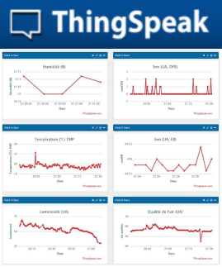

**Sensor Hub (Photon)**

Fire Sensor

Temp Sensore

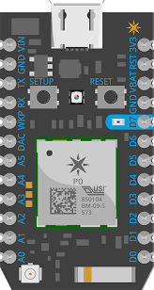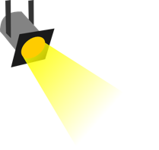

Humid Se

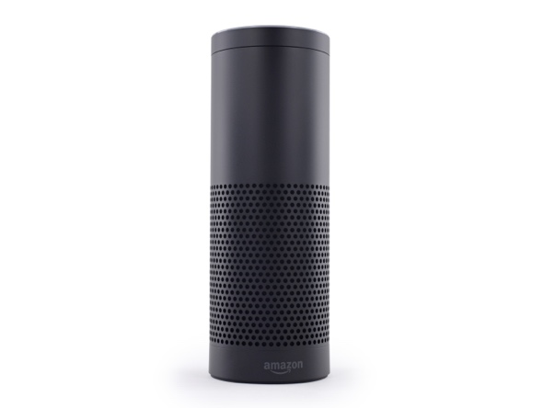

Light Sensor

**MMA8452**

**Movement**

**BMP 180**

**Temp, Pressure**

Amazon Echo

**Edison Based BLE hub**

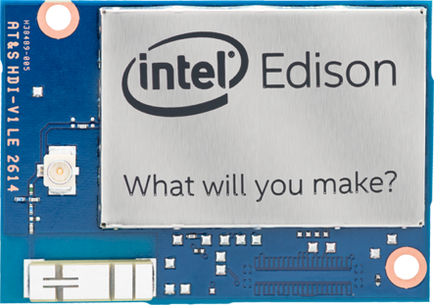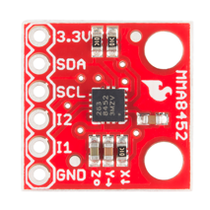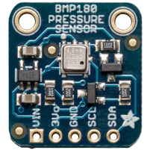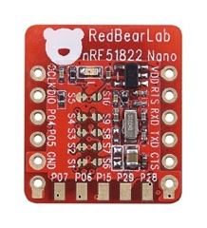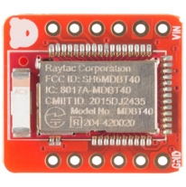

**Raspberry Pi Based Low energy hub**

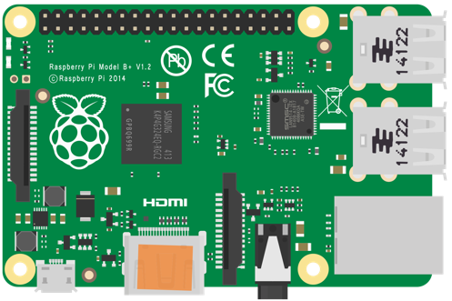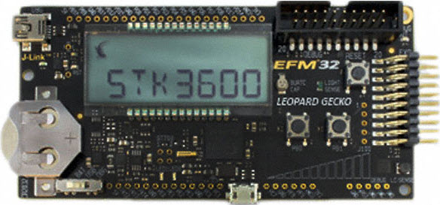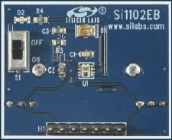

**Cap. Sense**

**LC Sense**

**Proximity Sensor**

**Temperature Sensor**

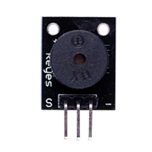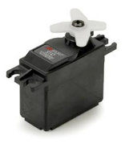

**Block Diagram of a Sensor Tag**

Sensor Circuit

RedBear

BLE Nano

Bluetooth Data to Central

**Block Diagram of the System**

Photon Sensor Hun

Temperature, Pressure, Acceleration, Humidity etc.

Fire Sensor, Humidity, Ambient Light, Temperature

Intel Edison

Set Points, Visualize Data on Graphs, UI, Override Commands

Leopard Gecko based Tag

ThingSpeak/ Sci-Kit Cloud for Data Handling

Rasp Pi 2

LESENSE Sensors (Proximity, Touch, Ambient Light)

User

Trigger Commands

Eg. Tweet, Twillio

Actuation Process (based on Trigger)

Interaction with UI to view data and alerts and Send Override Commands.

Amazon Echo (Alexa)

**Issues and What could not be completed.**

We were aiming to also integrate the TI sensor tag in the system but we had some problems in reading data from it. Also we broke the side switch which is used to switch the system ON.

Also we are having problems with sending commands using Alexa. This is due to the University’s Private Network. We need a public IP to get the data from Alexa to actuate something.

We implemented the EEPROM Emulation but there are inconsistencies with our code.

We believe we could have made the system more consistent and given a better demo without making you and Shiva wait.

**Summary**

This was a very challenging project. We had a lot in mind and were able to implement most of it. We learnt a lot of new things.

We leant in depth about BLE services and learned to make a custom service. We still have to learn to write code to read from the custom library. This is the reason we have used existed profiles (Heart Rate) to receive data/send data.

We learnt different platforms to create a multiprotocol Wireless Sensor Network. Interfaced different IoT APIs with our project.

We learnt the Alexa API which is really fun to use. We created some models using sketch-up and learnt some 3D prototyping.

We learnt that anything that can go wrong will go wrong! You just have to be agile. Try to fix things with a new approach. We kept pretty much to the timeline apart from a few deviations.

We learnt Python in more depth. Also got to try a couple of new sensors.

Key Dates:

|  |  |
| --- | --- |
| Duration (Week) | Task |
| ~~03-13 to 03-19 (Week 1)~~ | ~~Acquiring Parts and Research~~ |
| ~~03-20 to 03-26 (Week 2)~~ | ~~Getting Sensor Tags ready (almost done)~~ |
| ~~03-27 to 04-02 (Week 3)~~ | ~~Finishing up with Sensor Tags~~ |
| ~~04-03 to 04-09 (Week 4)~~ | ~~Setting up the Sensor Network on Raspberry PI~~  ~~Complete Sensor Tags~~ |
| ~~04-10 to 04-16 (Week 5)~~ | ~~Setting up the Web Server using selected Platform~~  ~~EEPROM Emulation~~ |
| 04-17 to 04-23 (Week 6) | ~~Complete an Actuation System like the Automatic Window Blinds.~~  Integration with Amazon Echo |
| 04-23 to 04-25 (Week 7) | Testing and Finishing up |
| 04-26 (Week 7) | Project Demo |

We kept to the schedule more or less which has happened the first time with us. It was due to the timely updates and status reports that were required which pushed us to complete our work on time.

**Photos**

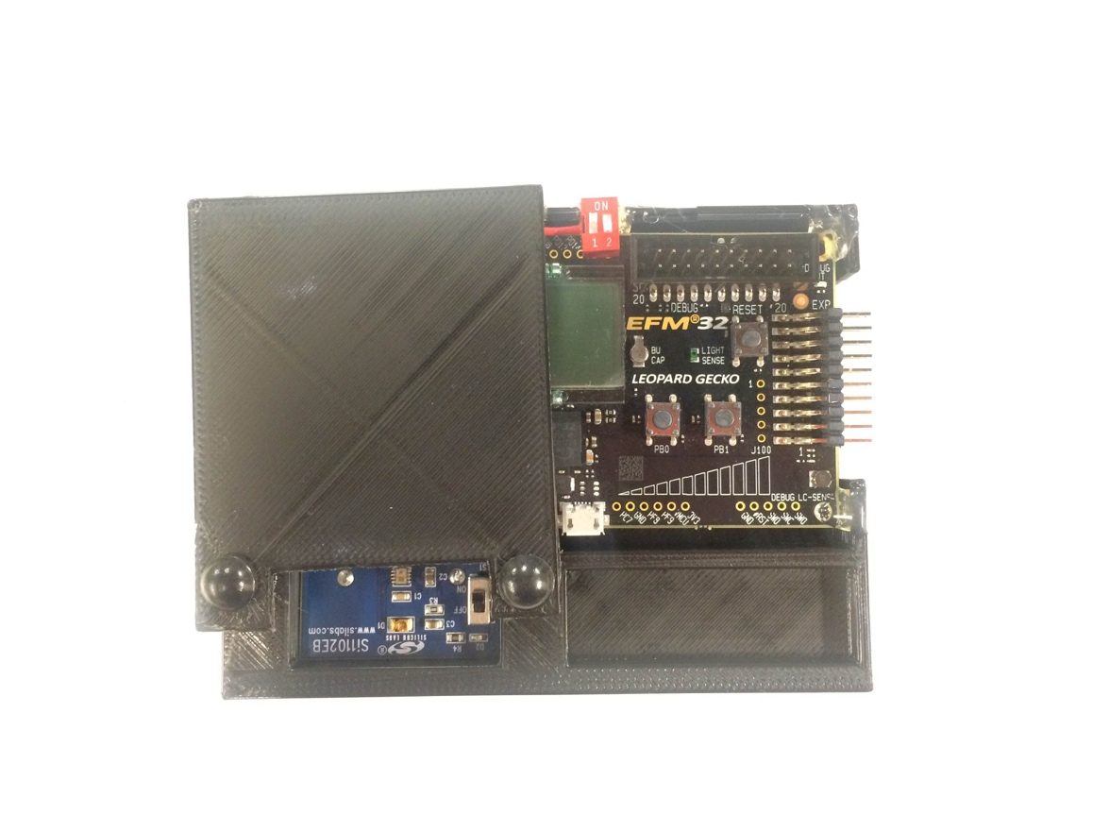

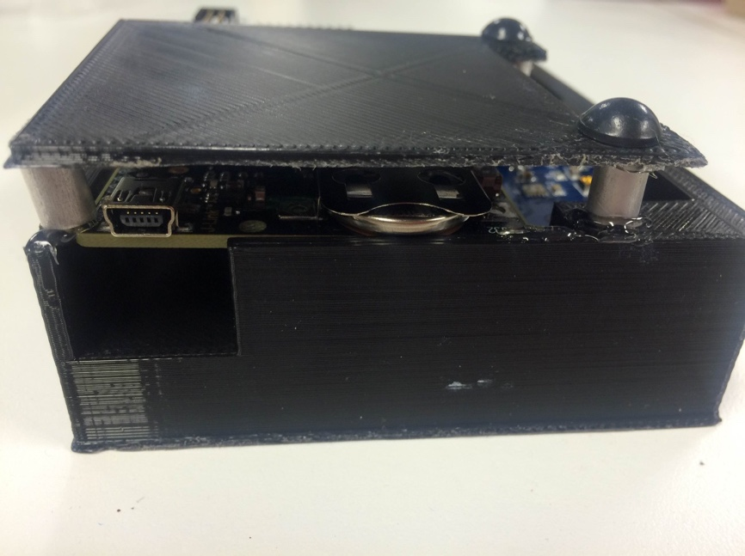Figure 1 Leopard Gecko with housing (Top View)

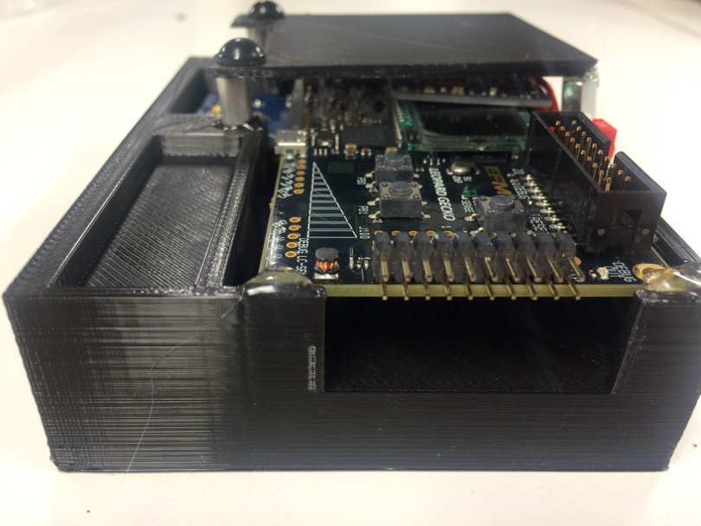Figure 2 Leopard Gecko (Side View 1)

Figure 3 Leopard Gecko (Side View 2)

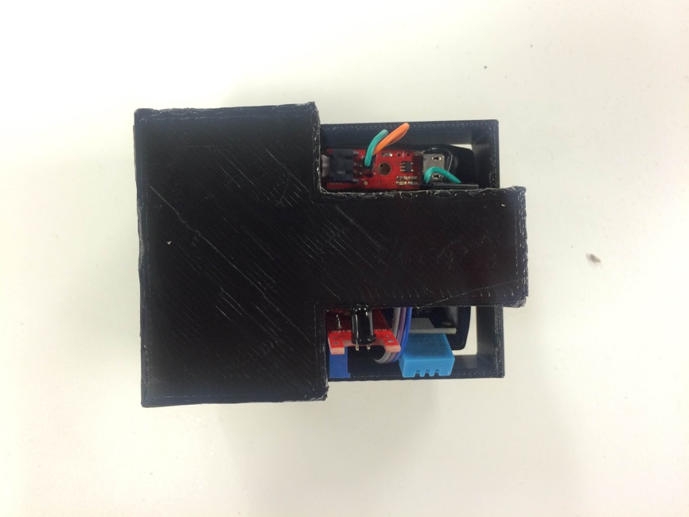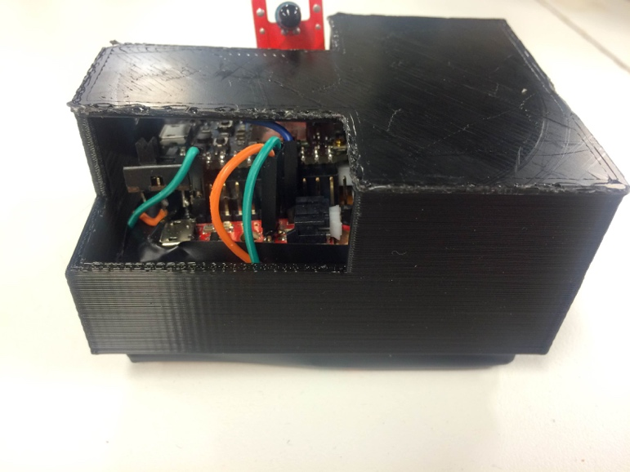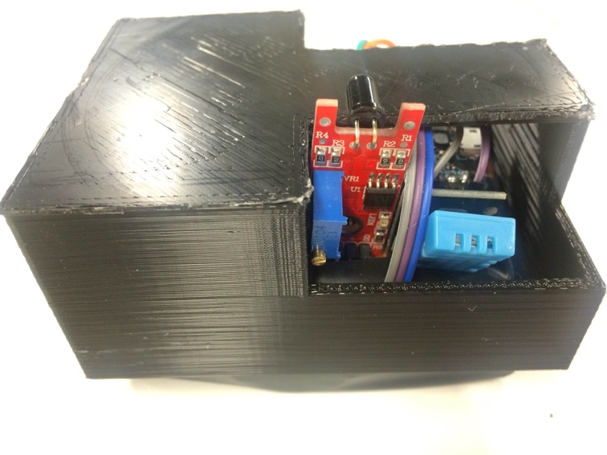

Figure 4 Photon Sensor Hub with Housing (Side View 1)

Figure 5 Photon Sensor Hub with Housing (Side View 2)

Figure 6 Photon Sensor Hub with Housing (Top View)

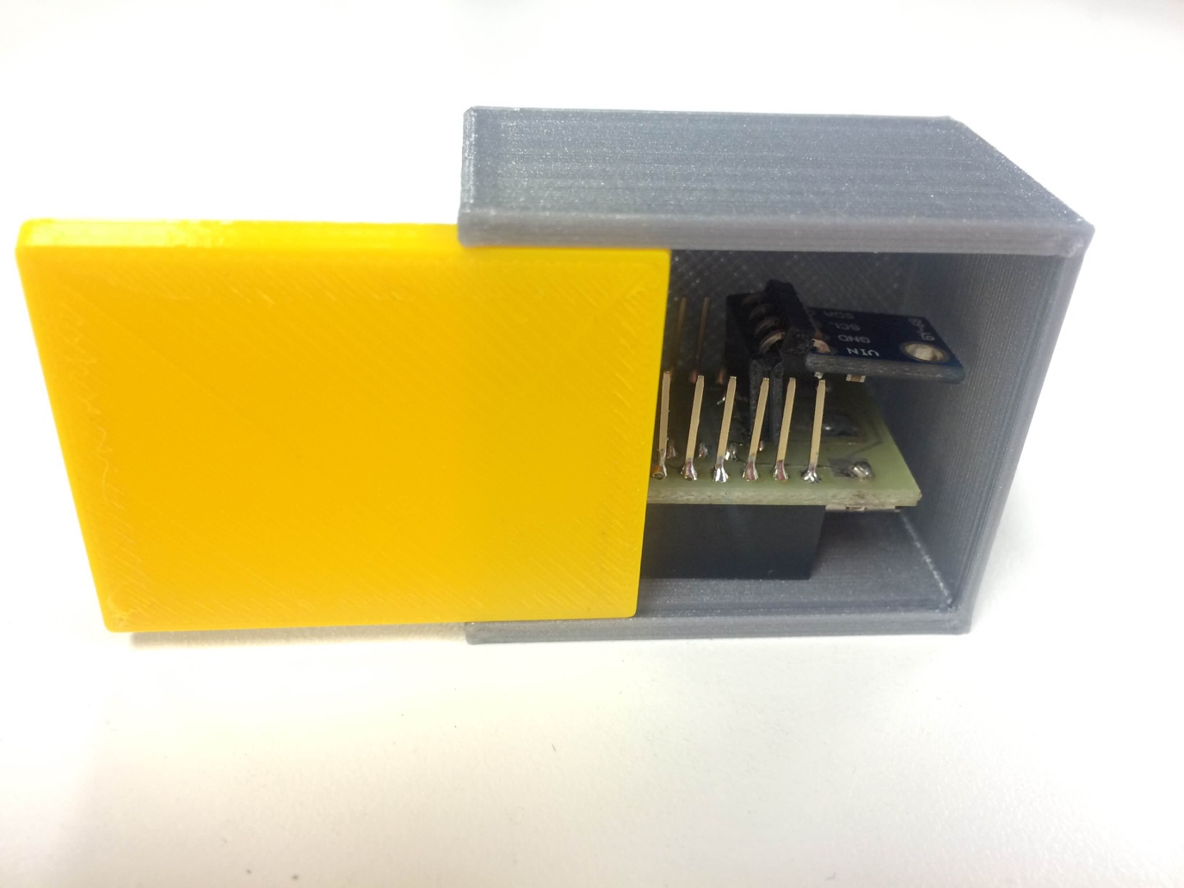

Figure 7 Accelerometer Cube (with Red Bear Nano)

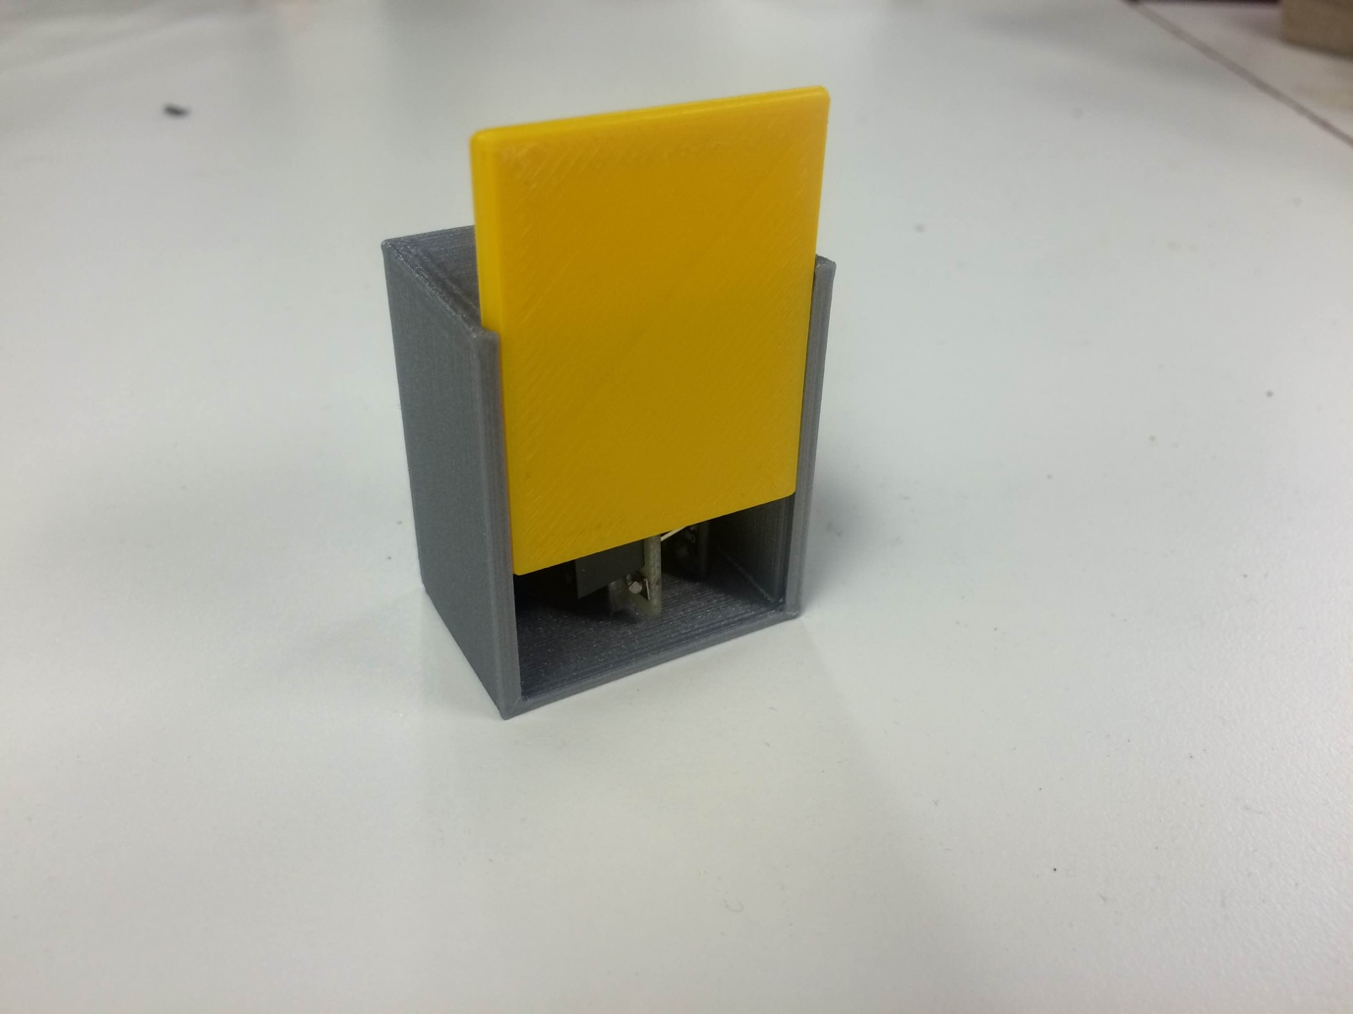

Figure 8 Temperature and Pressure Cube (with Red Bear Nano)

**Acknowledgements**

We would like to conclude by thanking a few people without whose help this project would have not been possible.

Firstly, we would like to Thank you Prof. Graham for scoping the project so well and giving us ample time for the project. We really liked the way the project was structured with the regular updates, it pushed us to complete it on time.

We would also Thank you for the forum and helping everyone through that medium, though we were not able to use that help much I believe it was really helpful for other students.

We would also extend our thanks to our TA, Shivashankar Gunashekhar for his help and suggestions during the project and otherwise. He has been a really hard-working TA and helped a lot of students like us during the entire semster. We would also Thank our friend Akshay Singh for helping us during the HackCU.

Lastly we would like to thank our friend from Aerospace Engineering for helping us in making the 3D parts using solid-works, without her help it wouldn’t have been easier to make the parts this quickly.